

Beneficial Bites

Blueberries

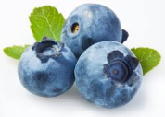Health Benefits:

* One of the highest antioxidant capacities of all foods
* May improve memory
* Acts as an anti-inflammatory
* Lowers LDL cholesterol
* Low in sugar

Did you know…?

* Blueberries are one of the few fruits native to North America
* The antioxidants in blueberries give the fruit their vibrant color
* Blueberries are the second most popular berry in the US diet behind strawberries
* 95% of the world’s blueberry crop is grown in North America
* Blueberries have a “dusty” appearance due to something called “wax bloom”. This protects the fruit from water and other damage. Do not wash off the bloom until just before eating!



Beneficial Bites

Blueberries

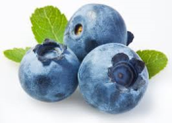Health Benefits:

* One of the highest antioxidant capacities of all foods
* May improve memory
* Acts as an anti-inflammatory
* Lowers LDL cholesterol
* Low in sugar

Did you know…?

* Blueberries are one of the few fruits native to North America
* The antioxidants in blueberries give the fruit their vibrant color
* Blueberries are the second most popular berry in the US diet behind strawberries
* 95% of the world’s blueberry crop is grown in North America
* Blueberries have a “dusty” appearance due to something called “wax bloom”. This protects the fruit from water and other damage. Do not wash off the bloom until just before eating!



Beneficial Bites

Blueberries

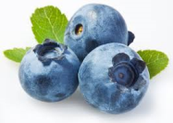Health Benefits:

* One of the highest antioxidant capacities of all foods
* May improve memory
* Acts as an anti-inflammatory
* Lowers LDL cholesterol
* Low in sugar

Did you know…?

* Blueberries are one of the few fruits native to North America
* The antioxidants in blueberries give the fruit their vibrant color
* Blueberries are the second most popular berry in the US diet behind strawberries
* 95% of the world’s blueberry crop is grown in North America
* Blueberries have a “dusty” appearance due to something called “wax bloom”. This protects the fruit from water and other damage. Do not wash off the bloom until just before eating!

Check out the August menu for these “Blueberry” foods

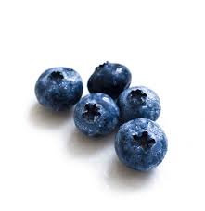

Featured Recipes:

* Fresh Blueberry Parfait
* Triple Berry Custard
* Blueberry Muffin
* Blueberry Cobbler
* Blueberry Trifle Dessert

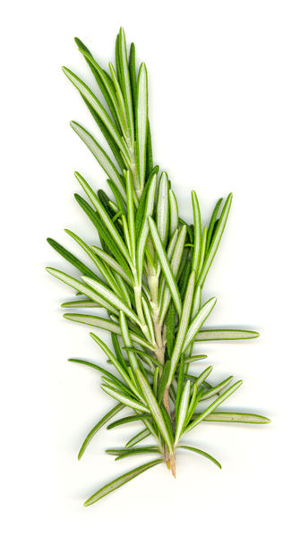

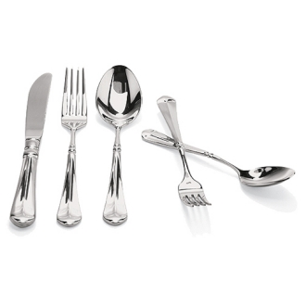

Created by Kathryn Hoff, MS,

UW-Stout Dietetic Intern, 2015

Check out the August menu for these “Blueberry” foods

Created by Kathryn Hoff, MS,

UW-Stout Dietetic Intern, 2015



Featured Recipes:

* Fresh Blueberry Parfait
* Triple Berry Custard
* Blueberry Muffin
* Blueberry Cobbler
* Blueberry Trifle Dessert



Check out the August menu for these “Blueberry” foods

Created by Kathryn Hoff, MS,

UW-Stout Dietetic Intern, 2015



Featured Recipes:

* Fresh Blueberry Parfait
* Triple Berry Custard
* Blueberry Muffin
* Blueberry Cobbler
* Blueberry Trifle Dessert

