Beets are a tuberous root vegetable. You can consume both the green leafy portion of the plant and the delicious root!
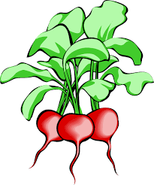
Beet Nutrition:
- Excellent source of folate
- Excellent source of fiber, potassium and vitamin C
- Excellent source of unique pigment antioxidants (Betalain)
- Low in fat and calories
- Great source of B vitamins
Stay True to Your Roots …
Pickled beets are a traditional favorite food throughout the world
Versatile and easy to use in both sweet and savory dishes
Beets can be enjoyed raw or cooked
Beet juice is used to enhance the food color of many other red foods
Beets can be deep purple, red, white, yellow or rainbow
Packed with folate and loaded with beneficial antioxidants
Freshest availability is between June and October
Important source for the production of refined sugar
Several Russian centenarians include beets routinely in their diets
Beets
Choose fresh, bright, firm beets that are smaller in size. Avoid soft, large beets. Choose beet greens that appear fresh, tender and have a lively green color.

The beet must be uprooted!…
…add raw greens or beets to salads
…make beet jelly or chocolate cake
…sauté the greens
…roast beet roots
…pickle your beets
…freeze cooked beets for later use

