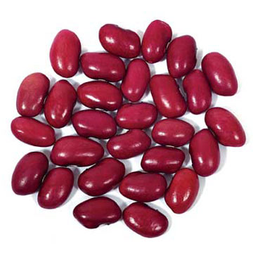

Adding more beans to your diet:
Prepare soups, stews, and casseroles with beans.
Use pureed beans as a base for spreads and dips.
Add garbanzo beans or black beans to salads.
If you don’t have a certain type of bean, you can easily substitute another.

Reducing the gas factor:
Change the water several times during soaking.
Simmer beans slowly until they are tender.
Add digestive aids, like Beano, when eating beans to help reduce the amount of gas they produce.
“Bean” There, Done That

Bean Facts
Navy beans are the official vegetable of Massachusetts.
Chinese long beans can grow up to 18 inches long.
Beans are an excellent and low-cost form of protein.
Dove Creek, Colorado is the Pinto Bean Capital of the world.
The fiber in beans is good for gastrointestinal health.
Garbanzo Beans, or chickpeas, are the most widely consumed bean in the world.

Beneficial Bites
Beneficial Bites

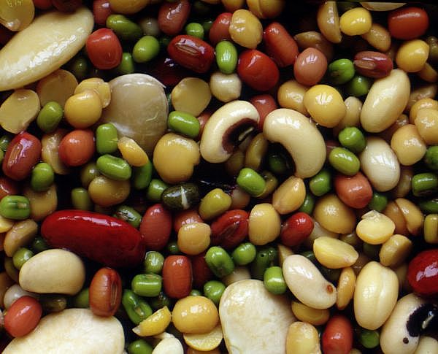

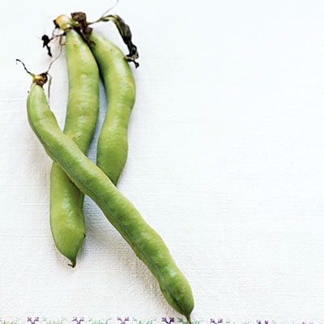
Written and created by Robyn Verschay, UW-Stout Dietetic Intern, 9/2009

