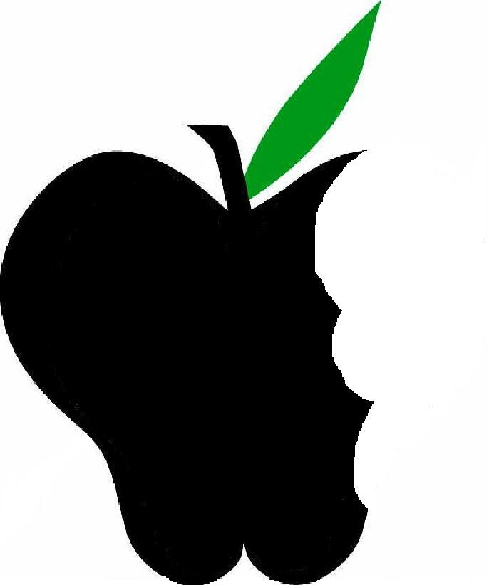 Banana
- What is a Banana
  - The word “banana” is a general term that covers a number of species and hybrids within the genus Musa, of the Musaceae family of flowering plants
  - Banana plants are the largest plants on earth without a woody stem
    - They are actually giant herbs belonging to the same family as lilies, orchids, and palms
  - Though there are hundreds of cultivars of bananas, the most popular, and familiar variety is the Yellow Cavendish (what we find in grocery stores)
  - The many types of bananas can be divided into two broad groups: dessert bananas and plantains
- Dessert bananas, which include the Yellow Cavendish variety, can be eaten raw or cooked
- Plantains require cooking prior to eating. They are much starchier and have a flavor that resembles squash or potatoes.
  - Different varieties of bananas that you may see in grocery stores include:
    - Dwarf or finger bananas, which are smaller, sweeter versions of the Cavendish
    - Apple bananas, which are short, plump bananas with an apple aftertaste
    - Red bananas, which are short, chunky bananas with red skin that turns purple as they ripen; this variety is particularly sweet and creamy in flavor
  - Bananas are the most popular fresh fruit in the U.S.
- They provide a convenient and inexpensive way to add fruit to a healthy diet
- They are not only very portable, but also require no advance preparation
- A perennial crop, they are grown year-round. In fact bananas are harvested every day of the year!
  - In the U.S., bananas are imported from Colombia, Costa Rica, Ecuador, Guatemala, Honduras, Panama, Mexico, and Nicaragua

- History of Bananas
  - Bananas have been grown for over 1 million years
  - Some researchers believe that they are the first fruit to ever be cultivated
  - Throughout history, each time a different group of people was introduced to them, bananas received a new name
    - Centuries ago, names included banna and ghana and even funana
    - West Africans are credited with giving the banana its permanent name
  - Native to Southeast Asia, bananas are thought to have originated in Malaysia because so many varieties are found there
  - From there, bananas made their way to India, where they are thought to have become the first fruit farmed by man
    - According to Indian legend, Indian wise men meditated under the shady green leaves of banana plants, dubbing bananas the “Fruit of the Wise Men”
    - In 327 B.C., after conquering India, Alexander the Great discovered bananas being cultivated and was thereafter credited with introducing them to the Western world
  - Eventually, bananas reached Madagascar and spread through Africa via the slave trade
  - Portuguese sailors discovered the banana in 1402 and brought it with them to the Canary Islands where they established the world’s first banana plantations
    - From there, Tomas de Berlanga, a Portuguese monk, sailed to the Caribbean with banana root stocks and planted them in the rich, fertile soil of Santo Domingo
    - Popularity of the banana then spread through the Caribbean and Central American
  - Bananas were officially introduced in America at the 1876 Philadelphia Centennial Exhibition
    - Each banana was wrapped in foil and sold for 10 cents
  - Hindus regard the banana as a symbol of fertility and prosperity because of its continuous reproduction
    - Leaves and fruits are deposited on doorsteps on houses where marriages are taking place
  - Early Hawaiians used a young banana plant as a truce flag in wars

- Nutrition & Health Benefits
  - Basic health benefits
- Bananas are fat-, sodium-, and cholesterol-free!
- A single serving (one medium-sized banana) provides 12% of your recommended daily fiber intake, which is important for healthy digestive function
  - Vitamins and minerals
- Bananas are high in Vitamin B6, which contributes to red blood cell formation and transporting iron through the body, which in turn reduce feelings of fatigue
- Bananas are also a good source of Vitamin C, another fighter of fatigue. In addition, Vitamin C aids in the maintenance of skin, bones, cartilage, blood vessels, gums, and teeth
- Bananas are best-known for their Potassium content, providing 13% of the daily value for adults over 50
  - Potassium can help to lower blood pressure by reducing the negative effects that sodium has on blood pressure (however, those taking BP medication such as ACE inhibitors should consult their physician for guidance on potassium intake)
  - Other benefits of Potassium include decreased risk of both kidney stones and bone loss
  - Some studies have suggested that greater potassium intake is associated with a decreased risk of stroke; similarly, eating potassium-rich foods may help prevent osteoporosis
- Bananas are also rich in Manganese, another mineral that helps to maintain healthy bones
- Though in small amounts, bananas provide calcium, copper, iodine, iron, phosphorus, zinc, and Vitamin A as well
  - Bananas are an excellent source of antioxidants
- Both Vitamin C and Manganese have antioxidant properties as well, meaning they reduce levels of harmful free radicals found in our bodies, protecting our cells from oxidative damage

- Selection, Storage, & Handling of Bananas
- Selection
- Choose bananas that are firm and free of bruises or brown spots
- Avoid those with a gray tint or dull skin
- Best eating quality is reached when the skin reaches a solid yellow color
- Under-ripe bananas show green tips and almost no yellow color; these bananas have not developed their full flavor and have a greater starch content
- Overripe bananas will give off a strong odor; nearly all of their starch will have been converted to fruit sugars
- Storage
- To ripen bananas, leave at room temperature for a couple of days
- The longer they are kept at room temperature, the darker, sweeter, and softer they will become
- For best results, hang your bunch of bananas in a cool, shady place
- Once ripe, bananas will store in the refrigerator for 3 to 5 days
  - Don’t be discouraged--the peel may turn brown, but the fruit itself will not change
- If your bananas are too green or under-ripe for your taste, put them in a paper bag along with an apple or tomato overnight; this will speed the ripening process
  - Ripe fruits give off ethylene gas, which helps to initiate and stimulate the ripening process
- If they become too ripe for your taste before you get the chance to eat them, peel, put in a freezer bag, and freeze for later use in baked goods, smoothies, or shakes
- Like in the refrigerator, bananas will also darken when frozen
  - Though they tend to lose their texture after freezing and thawing, they can be enjoyed frozen whole as popsicles or as a puree
- Handling
- Unlike many fruits, bananas are pretty low maintenance! Just peel and enjoy!
- To prevent cut bananas from turning brown, use citrus juice, such as orange, lemon, lime, etc.

- Cooking and Serving of Bananas
  - Before use or eating, cut away any bruised or damaged areas
  - For banana bread and other baked goods, use very ripe bananas with brown-flecked or almost completely brown skin for greater banana flavor
    - For a lower sugar content, use bananas that are less ripe
  - Serving ideas
    - Roll bananas in low-fat granola and freeze on a stick for a cool treat
    - Make use of the naturally sweet flavor of bananas by adding them to plain yogurt or smoothies
    - Add a serving of fruit to your breakfast by substituting sliced bananas for sugar on your oatmeal or cereal
    - Bake peeled bananas at 375° F for 15-18 minutes and sprinkle with cinnamon or add to yogurt

- Fun Facts
  - Bananas are the most popular fresh fruit in the U.S.
    - Over 4 million tons are imported to the U.S. every year
    - The average person eats 33 pounds of bananas each year
    - More than 96% of American households purchase bananas at least once a month
  - More than 500 varieties are grown around the world
  - They are grown in every humid tropical region of the world, and constitute the 4th largest fruit crop worldwide, amounting to 28 million tons annually
  - Though most of the U.S. supply of bananas comes from Latin America, many dooryard varieties are supported by Florida’s climate, including the Apple Banana, the Hua Moa, and the Dwarf Cavendish
  - The inside of a banana peel is a great shoe polisher for patent leather!
  - Compared to an apple, a banana provides four times the protein, twice the carbohydrate, three times the phosphorus, five times the vitamin A and iron, and twice the other vitamins and minerals.
    - As a rich source of potassium as well, it might be appropriate to change the popular phrase to “A banana a day keeps the doctor away”
  - In 2001, there were more than 300 banana-related accidents in Britain, mostly due to people slipping on skins
  - In many South Asian and Southeast Asian countries, banana leaves are used as plates or serving vessels for different types of street food due to their large size and flexible, waterproof quality
    - Banana leaves are also used to wrap grilled or steamed foods, providing a subtle, sweet flavor

- Activities for Bananas
- Look at the different varieties (use pictures if you can’t find variety in store)
- Taste an under-ripe, just ripe, and overripe banana
  - Under-ripe will taste astringent, gummy, and apple-like with a very firm texture
  - Overripe: dry, mealy, starchy
- Healthy banana splits!
  - Substitute vanilla frozen yogurt for the ice cream
  - Use fresh fruits instead sugary toppings

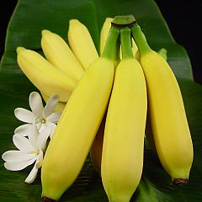
The Apple Banana
Looks like other bananas except is short & plump.
The Red Banana
Softer & Sweeter than the Cavendish

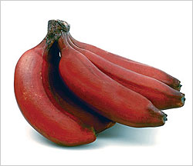

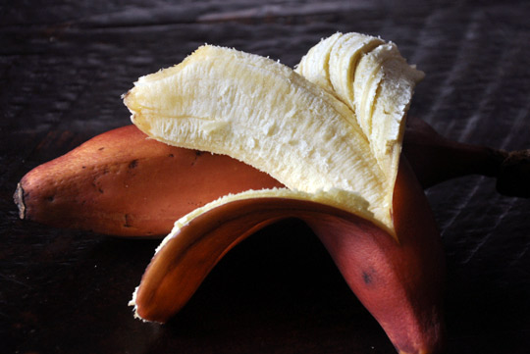

The Hua Moa Banana

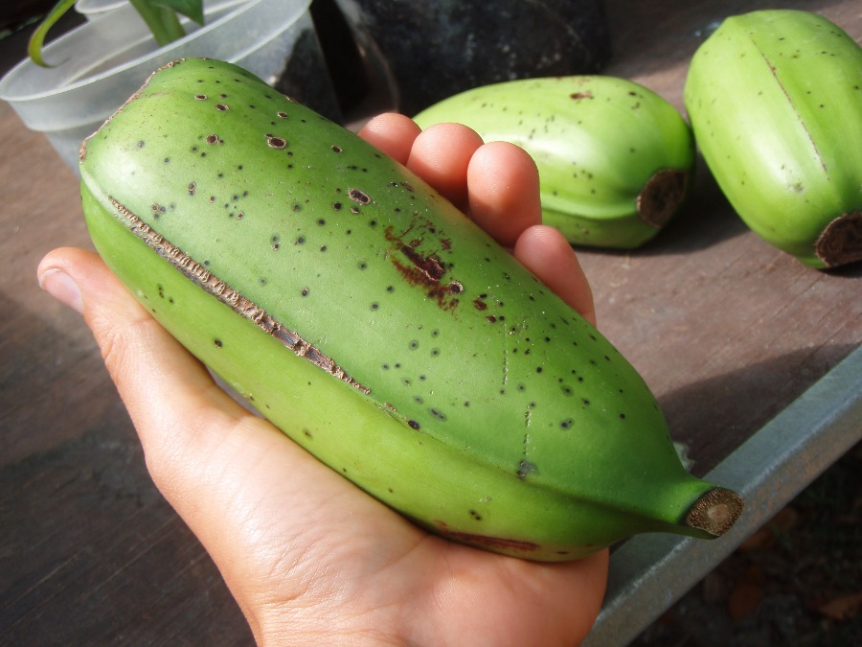

The Finger or Dwarf Banana

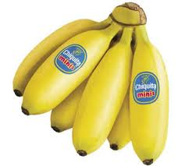

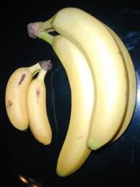

As you can see, the finger or dwarf banana is much smaller than your typical banana

The Plantain

