Asparagus

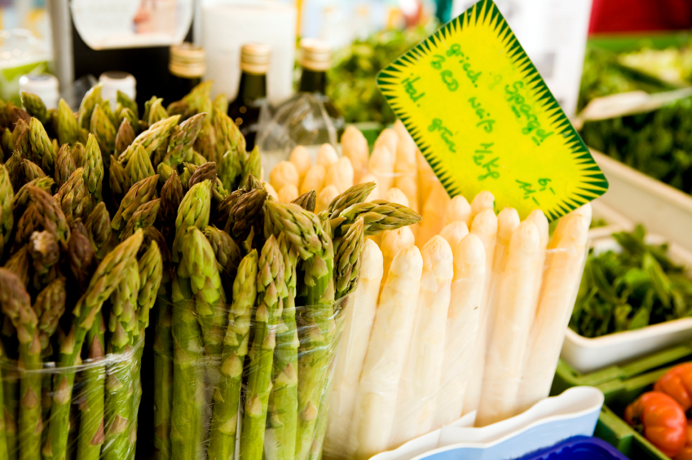
Asparagus is a vegetable from the Lily family that received its’ name from the Greek language meaning “sprout” or “shoot”.
This unique vegetable is grown in three varieties: green, white, and purple with the green variety being the most nutritious as well as the most commonly grown in the United States. The white variety is more common in Europe and remains white because it is grown underground; therefore photosynthesis cannot occur.

Beneficial Bites

Asparagus is a well-balanced vegetable providing several nutrients including folic acid, Vitamin C, thiamin, potassium, and Vitamin B6. It also contributes no fat and is low in sodium and calories.
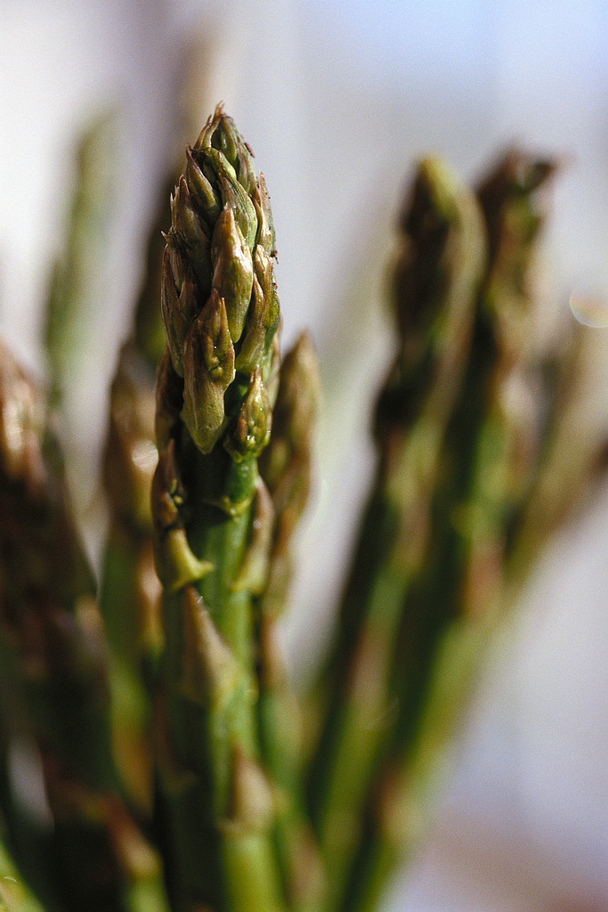

This nutrient dense vegetable is a great source of antioxidants. These tender stalks provide rutin and glutathione; antioxidants that aid in removing toxic substances from the body, improving immune function, and repairing damaged DNA.
Beneficial Bites

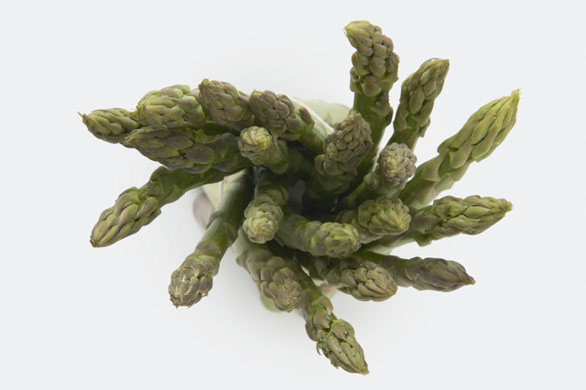
The Great Debate….does asparagus make your urine smell strange?

Asparagus is made up of a sulfur containing compound methyl mercaptan and an amino acid asparagine. The metabolization of these compounds is thought to be the cause of the strange urine smell.
Another theory claims that only half of the population has the gene that is required to break down the compounds in asparagus and if they do not break down the compounds then no smell is emitted!
Beneficial Bites

