Health Benefits:
- Excellent source of folic acid and other B vitamins.
- Good source of potassium and low in sodium both of which are important for blood pressure control.
- Rich source of rutin, a compound that strengthens blood vessel walls.
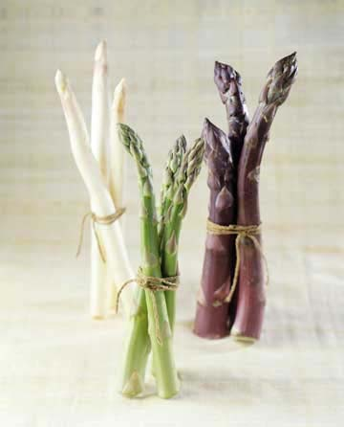
- Rich source of glutathione, a compound involved in removing toxic substances, protecting cells and repairing damaged DNA!

Interesting Facts:
- Asparagus comes in three colors…green, white and
purple.
- Most Europeans eat white asparagus.
- White asparagus comes from the same plant that produces green asparagus…the only difference is that the stalks are grown under the soil.
- Asparagus can grow as much as 10” in a single day! Some say you can actually watch it grow.
- China is by far the leading producer of asparagus, followed by Peru and Mexico.

Health Benefits:
- Excellent source of folic acid and other B vitamins.
- Good source of potassium and low in sodium both of which are important for blood pressure control.
- Rich source of rutin, a compound that strengthens blood vessel walls.
- Rich source of glutathione, a compound involved in removing toxic substances, protecting cells and repairing damaged DNA!

Interesting Facts:
- Asparagus comes in three colors…green, white and
purple.
- Most Europeans eat white asparagus.
- White asparagus comes from the same plant that produces green asparagus…the only difference is that the stalks are grown under the soil.
- Asparagus can grow as much as 10” in a single day! Some say you can actually watch it grow.
- China is by far the leading producer of asparagus, followed by Peru and Mexico.

Health Benefits:
- Excellent source of folic acid and other B vitamins.
- Good source of potassium and low in sodium both of which are important for blood pressure control.
- Rich source of rutin, a compound that strengthens blood vessel walls.
- Rich source of glutathione, a compound involved in removing toxic substances, protecting cells and repairing damaged DNA!

Interesting Facts:
- Asparagus comes in three colors…green, white and
purple.
- Most Europeans eat white asparagus.
- White asparagus comes from the same plant that produces green asparagus…the only difference is that the stalks are grown under the soil.
- Asparagus can grow as much as 10” in a single day! Some say you can actually watch it grow.
- China is by far the leading producer of asparagus, followed by Peru and Mexico.

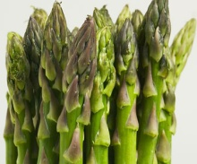
Enjoy Asparagus all month long in your Meals on Wheels

- Garlic Buttered Asparagus
- Creamy Asparagus Soup
- Asparagus w/Warm Bacon Dressing
- Asparagus w/Cheese Sauce

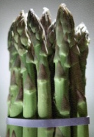

Asparagus Harvest

P | S | J | J | Z | G | R | B | S | N | N | P
U | O | S | O | V | L | O | L | K | O | A | O
R | U | J | P | Q | U | L | A | E | T | G | T
P | P | J | B | E | T | K | N | E | G | I | A
L | S | D | A | L | A | S | C | R | N | H | S
E | T | I | H | W | T | R | H | G | I | C | S
G | R | E | E | N | H | B | S | B | H | I | I
D | I | C | A | C | I | L | O | F | S | M | U
R | A | I | N | R | O | F | I | L | A | C | M
M | R | O | M | A | N | S | E | C | W | U | W
G | R | I | L | L | E | D | R | U | T | I | N
L | I | L | Y | F | A | M | I | L | Y | Y | A

Blanch California Folic Acid
Glutathione Greeks Green
Grilled Lily Family Michigan
Potassium Purple Romans
Rutin Salads Soups
Spears Washington White

Enjoy Asparagus all month long in your Meals on Wheels

- Garlic Buttered Asparagus
- Creamy Asparagus Soup
- Asparagus w/Warm Bacon Dressing
- Asparagus w/Cheese Sauce

Asparagus Harvest

P | S | J | J | Z | G | R | B | S | N | N | P
U | O | S | O | V | L | O | L | K | O | A | O
R | U | J | P | Q | U | L | A | E | T | G | T
P | P | J | B | E | T | K | N | E | G | I | A
L | S | D | A | L | A | S | C | R | N | H | S
E | T | I | H | W | T | R | H | G | I | C | S
G | R | E | E | N | H | B | S | B | H | I | I
D | I | C | A | C | I | L | O | F | S | M | U
R | A | I | N | R | O | F | I | L | A | C | M
M | R | O | M | A | N | S | E | C | W | U | W
G | R | I | L | L | E | D | R | U | T | I | N
L | I | L | Y | F | A | M | I | L | Y | Y | A

Blanch California Folic Acid
Glutathione Greeks Green
Grilled Lily Family Michigan
Potassium Purple Romans
Rutin Salads Soups
Spears Washington White

Enjoy Asparagus all month long in your Meals on Wheels

- Garlic Buttered Asparagus
- Creamy Asparagus Soup
- Asparagus w/Warm Bacon Dressing
- Asparagus w/Cheese Sauce

Asparagus Harvest

P | S | J | J | Z | G | R | B | S | N | N | P
U | O | S | O | V | L | O | L | K | O | A | O
R | U | J | P | Q | U | L | A | E | T | G | T
P | P | J | B | E | T | K | N | E | G | I | A
L | S | D | A | L | A | S | C | R | N | H | S
E | T | I | H | W | T | R | H | G | I | C | S
G | R | E | E | N | H | B | S | B | H | I | I
D | I | C | A | C | I | L | O | F | S | M | U
R | A | I | N | R | O | F | I | L | A | C | M
M | R | O | M | A | N | S | E | C | W | U | W
G | R | I | L | L | E | D | R | U | T | I | N
L | I | L | Y | F | A | M | I | L | Y | Y | A

Blanch California Folic Acid
Glutathione Greeks Green
Grilled Lily Family Michigan
Potassium Purple Romans
Rutin Salads Soups
Spears Washington White

