A+ For Apricots

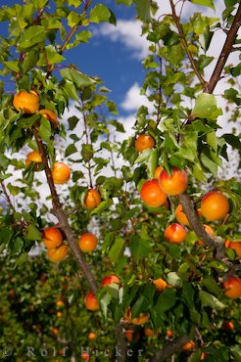
Apricots were said to be growing wild on the mountain slopes in China when they were first discovered.

Most of the U.S. grown apricots come out of the San Joaquin Valley of California.

are loaded with soluble and insoluble fiber.

But Fiber isn’t the only good reasons to choose apricots. This delicious fruit is a good source of these important nutrients…

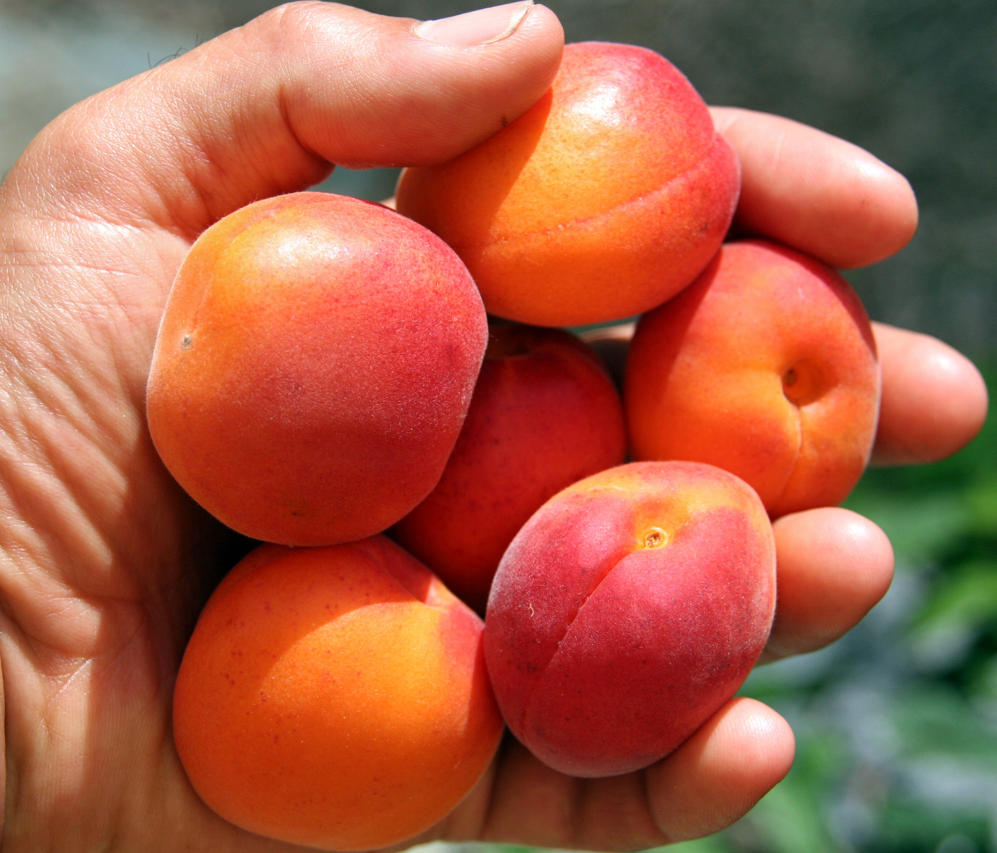
- Potassium
- Vitamin C
- Vitamin A
- Lycopene
- Iron
- Beta Carotene

Beneficial Bites

A+ For Apricots

Apricots were said to be growing wild on the mountain slopes in China when they were first discovered.

Most of the U.S. grown apricots come out of the San Joaquin Valley of California.

are loaded with soluble and insoluble fiber.

But Fiber isn’t the only good reasons to choose apricots. This delicious fruit is a good source of these important nutrients…

- Potassium
- Vitamin C
- Vitamin A
- Lycopene
- Iron
- Beta Carotene
Beneficial Bites

A+ For Apricots
Apricots were said to be growing wild on the mountain slopes in China when they were first discovered.

Most of the U.S. grown apricots come out of the San Joaquin Valley of California.

are loaded with soluble and insoluble fiber.

But Fiber isn’t the only good reasons to choose apricots. This delicious fruit is a good source of these important nutrients…

- Potassium
- Vitamin C
- Vitamin A
- Lycopene
- Iron
- Beta Carotene
Beneficial Bites

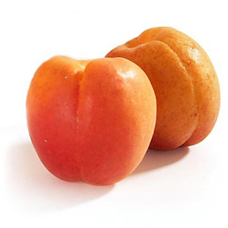
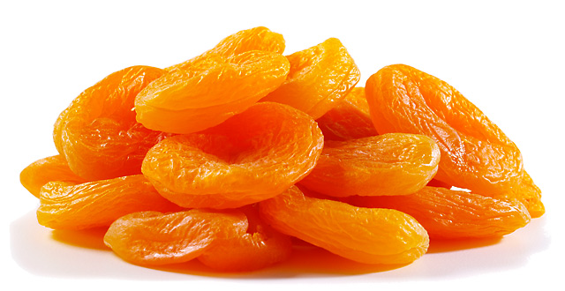
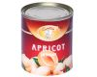
Beneficial Bites
Nutritionally, it doesn’t
matter if you choose fresh,
dried or canned apricots.
They are all healthy and
tasty additions to your diet.


Of course, not every form an apricot takes is nutritious, but there’s room in every healthy diet for a little jam!

Apricot Word Search

A | B | D | P | N | P | F | E | R | M | N | I
X | I | I | E | U | O | N | I | E | U | U | I
I | T | N | R | I | E | E | A | B | I | W | J
S | V | E | R | P | R | N | O | I | S | C | Q
G | E | I | O | O | I | D | E | F | S | A | S
D | Y | C | T | H | F | P | R | Q | A | N | V
V | Y | H | C | A | W | I | B | Z | T | N | J
L | K | R | V | G | M | I | L | B | O | E | U
T | V | I | T | A | M | I | N | A | P | D | N
X | L | O | I | R | O | N | N | E | C | D | E
E | G | N | A | R | O | E | J | C | Z | T | X
V | B | M | C | G | U | K | K | K | I | B | A

Search for these apricot-related words: California, Canned, China, Dried, Fiber, Iron, June, Lycopene, Orange, Pits, Potassium, Pureed, Vitamin A, Vitamin C, Wine
Beneficial Bites
Nutritionally, it doesn’t
matter if you choose fresh,
dried or canned apricots.
They are all healthy and
tasty additions to your diet.

Of course, not every form an apricot takes is nutritious, but there’s room in every healthy diet for a little jam!

Apricot Word Search

A | B | D | P | N | P | F | E | R | M | N | I
X | I | I | E | U | O | N | I | E | U | U | I
I | T | N | R | I | E | E | A | B | I | W | J
S | V | E | R | P | R | N | O | I | S | C | Q
G | E | I | O | O | I | D | E | F | S | A | S
D | Y | C | T | H | F | P | R | Q | A | N | V
V | Y | H | C | A | W | I | B | Z | T | N | J
L | K | R | V | G | M | I | L | B | O | E | U
T | V | I | T | A | M | I | N | A | P | D | N
X | L | O | I | R | O | N | N | E | C | D | E
E | G | N | A | R | O | E | J | C | Z | T | X
V | B | M | C | G | U | K | K | K | I | B | A

Search for these apricot-related words: California, Canned, China, Dried, Fiber, Iron, June, Lycopene, Orange, Pits, Potassium, Pureed, Vitamin A, Vitamin C, Wine

Beneficial Bites
Nutritionally, it doesn’t
matter if you choose fresh,
dried or canned apricots.
They are all healthy and
tasty additions to your diet.

Of course, not every form an apricot takes is nutritious, but there’s room in every healthy diet for a little jam!

Apricot Word Search

A | B | D | P | N | P | F | E | R | M | N | I
X | I | I | E | U | O | N | I | E | U | U | I
I | T | N | R | I | E | E | A | B | I | W | J
S | V | E | R | P | R | N | O | I | S | C | Q
G | E | I | O | O | I | D | E | F | S | A | S
D | Y | C | T | H | F | P | R | Q | A | N | V
V | Y | H | C | A | W | I | B | Z | T | N | J
L | K | R | V | G | M | I | L | B | O | E | U
T | V | I | T | A | M | I | N | A | P | D | N
X | L | O | I | R | O | N | N | E | C | D | E
E | G | N | A | R | O | E | J | C | Z | T | X
V | B | M | C | G | U | K | K | K | I | B | A

Search for these apricot-related words: California, Canned, China, Dried, Fiber, Iron, June, Lycopene, Orange, Pits, Potassium, Pureed, Vitamin A, Vitamin C, Wine

