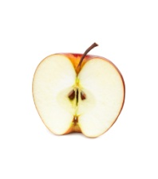
Apple-liceous

P P G G U T W E K M G X N U E L C
M P S A A E R E Z R C R F U J I G
C E Z I A L M E A I U I I Q K T X
I E K L R O A N D B O B N F O F S
R J T U R C N I E I W W A T A R A
Y H J C S Y E A C R C L P M O A N
Y S J M S P R L B E U Y P M D S T
V Z M M I B I T P D G N L A R R H
W E I J L I T A N P I O E K H F Z
R T C O R T L A N D A T P D C N O
H B S O G E I D C T G G I R B S A
J Z A G S M H H K B U N E P H C R
A Z R M J X C R L V C I T D F Z N
E L P P A K S E D X P H P W X E E
I K I A V D P D B D B S S K W U E
E C U A S E L P P A C A D I I R R
A H D M Y Q Y U F K I W A T N W G

APPLE APPLECRISP APPLESAUCE
APPLE PIE CIDER ROME
BRAEBURN MCINTOSH GREEN
CORTLAND FUJI RED
GALA GRANNY SMITH WASHINGTON WEALTHY
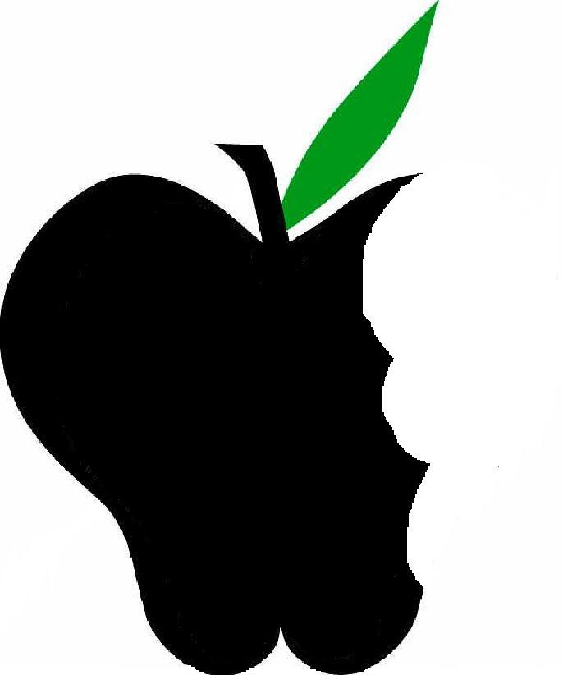
Created by Andrea Griffin, University of Wisconsin-Stout Dietetic Intern, September 2011
Created by Andrea Griffin, University of Wisconsin-Stout Dietetic Intern, September 2011

Apple-liceous

P P G G U T W E K M G X N U E L C
M P S A A E R E Z R C R F U J I G
C E Z I A L M E A I U I I Q K T X
I E K L R O A N D B O B N F O F S
R J T U R C N I E I W W A T A R A
Y H J C S Y E A C R C L P M O A N
Y S J M S P R L B E U Y P M D S T
V Z M M I B I T P D G N L A R R H
W E I J L I T A N P I O E K H F Z
R T C O R T L A N D A T P D C N O
H B S O G E I D C T G G I R B S A
J Z A G S M H H K B U N E P H C R
A Z R M J X C R L V C I T D F Z N
E L P P A K S E D X P H P W X E E
I K I A V D P D B D B S S K W U E
E C U A S E L P P A C A D I I R R
A H D M Y Q Y U F K I W A T N W G

APPLE APPLECRISP APPLESAUCE
APPLE PIE CIDER ROME
BRAEBURN MCINTOSH GREEN
CORTLAND FUJI RED
GALA GRANNY SMITH WASHINGTON

