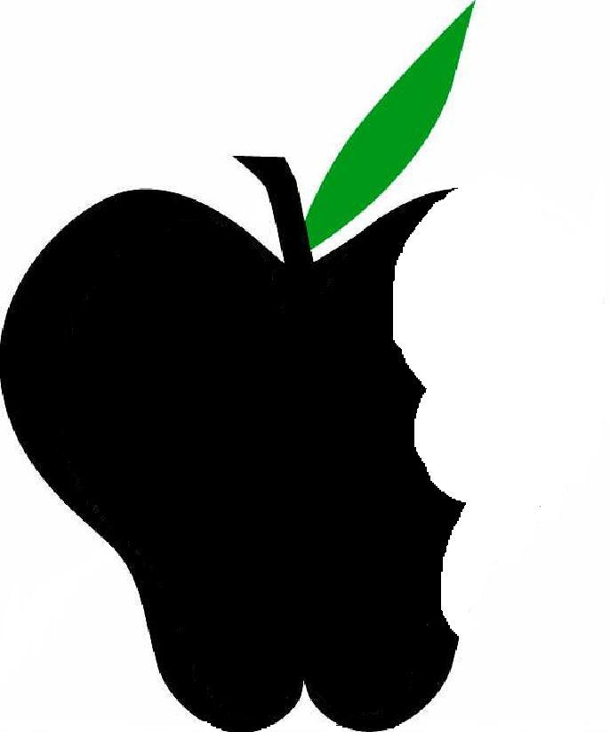
Varieties of apples:
There are 2,500 varieties of apples throughout the United States and 7,500 varieties throughout the world…..
*Rajka*Adanac
*Waltana*Filippa*Cellini
*Wolf River*Florina*Kanzi
*Falstaff*Catshead*Sandow
*Wealthy*Yates*Katy
Apples are a source of:
*Fiber*Vitamin C*Potassium
Apple-licious

Apple Facts
Apples are a great source of fiber which aids in digestion.
The crab apple is the only apple native to North America.
Apples are fat free, sodium free, and cholesterol free.
It takes 36 apples to make one gallon of apple cider.
Apples are the second most valuable fruit grown in the United States.
Apples are a member of the rose family.

Beneficial Bites
Beneficial Bites

Created by Andrea Griffin, UW-Stout Dietetic Intern, September, 2011

