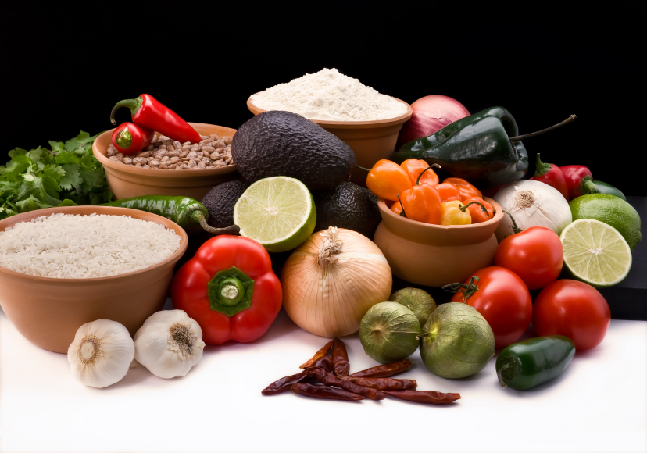
Recipe for: Maple Apple Turkey Burgers
3 tablespoons mayonnaise
3 tablespoon maple syrup1 tablespoon canola oil
2 teaspoons Dijon mustard¼ cup onion, diced
1 granny smith apple, peeled, cored, chopped1 egg
1 teaspoon Italian seasoning ¼ teaspoon salt
4 Hamburger buns¾ pound of ground turkey

In a small bowl, mix together mayonnaise, Dijon mustard, and 2 tablespoons of the maple syrup and set aside. Heat 1 tablespoon canola oil and cook onion and half of the chopped apple about 5 minutes. In a bowl combine ground turkey, egg, Italian seasoning, the remaining apple, the remaining syrup, and salt. Mold mixture into four patties. Remove cooked onion and apples from the skillet and place patties into the heated skillet. Cook 5 to 7 minutes for each side of the patty. Serve on hamburger buns with mayo mixture and garnish with cooked apples and onions.

Created by Andrea Griffin, University of Wisconsin-Stout Dietetic Intern, September, 2011

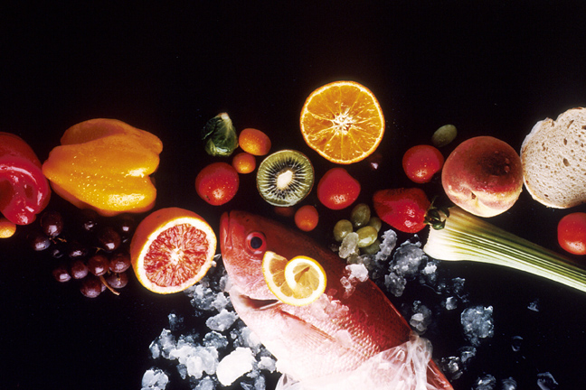
Recipe for: Broccoli Apple Salad

2 granny smith apples, chopped1- ¼ cups broccoli florets
¼ cup chopped green onion3 tablespoons craisins
½ cup mayonnaise2 teaspoons white wine vinegar
1 teaspoon sugar½ teaspoon lemon juice
¼ teaspoon salt4 bacon strips, cooked, crumbled
¼ cup cashews

In a bowl, combine apples, broccoli, onion, and craisins. In a small bowl, mix mayonnaise, vinegar, sugar, lemon juice, and salt. Pour over salad and coat evenly. Cover and refrigerate. Just before serving, add bacon crumbles and cashews.

Recipe for: Apple Salsa with Chicken

2 granny smith apples, cored, and cubed3 tablespoons lime juice
½ jalapeno pepper, seeded, diced¼ cup diced red bell pepper
¼ cup finely chopped green onion2 tablespoons fresh cilantro, chopped
1/3 cup walnuts, lightly toasted1 teaspoon ginger
¼ teaspoon salt4 boneless skinless chicken breasts
2 tablespoons olive oil

In a large bowl, combine apples, peppers, onion, cilantro, salt, ginger, and walnuts. Heat olive oil in a large skillet and cook chicken breast 5-6 minutes on each side. Remove from skillet and garnish chicken with apple salsa mixture.

Recipe for: Inside Out Apple-Crisp

4 medium apples½ cup orange juice
½ cup rolled oats¼ cup brown sugar
¼ cup slivered almonds½ teaspoon cinnamon
¼ teaspoon nutmeg1 tablespoon flour
¼ cup butter6 ounces vanilla yogurt (optional)

Preheat oven to 350 degrees. Cut the top and bottom of the apples off and core with a melon baller. Line apples in a baking dish and brush with 1 tablespoon orange juice. In a bowl, combine oats, sugar, almonds, cinnamon, nutmeg, flour. Stir in butter and stuff mixture into the cored apples. Pour remaining juice over apples, cover with foil and bake for an hour or until apples are tender. Remove from oven, let cool and serve with vanilla yogurt.

