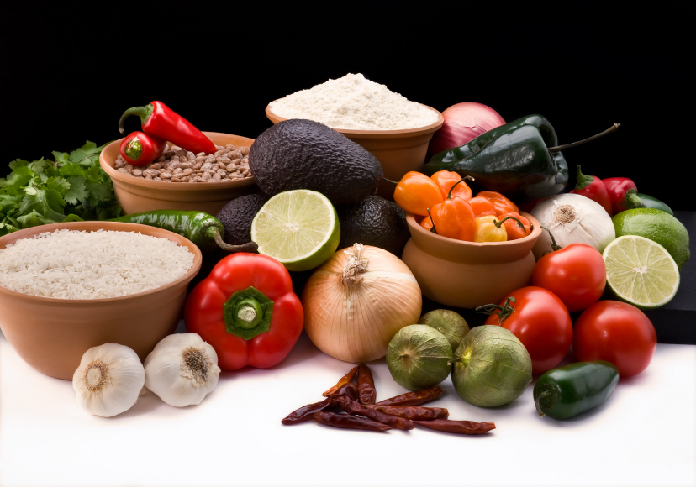
Recipe for: Apple-Craisin Salad

4 apples, cored and diced
¼ cup craisins
¼ cup walnuts
¼ cup dried cherries
8 ounces vanilla yogurt

Place walnuts on a sheet pan and toast in the oven (350 degrees for 5-6 minutes). Let cool and combine with apples, craisins, and cherries in a bowl. Toss with vanilla yogurt until evenly coated.

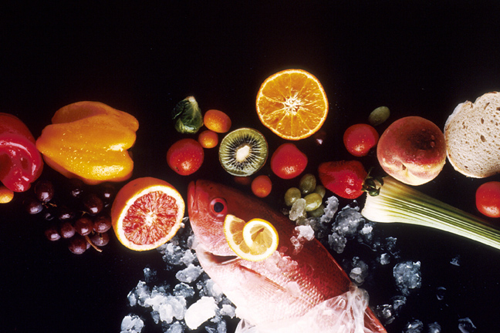
Recipe for: Apple Chutney Chops

2 apples, peeled, cored, and diced¼ cup diced onion
½ teaspoon ginger1 teaspoon cinnamon
½ teaspoon nutmeg2 tablespoon brown sugar
2 tablespoons white wine vinegar¼ cup raisins
4 pork loin chops

Combine apples, ginger, nutmeg, onion, cinnamon, brown sugar, raisins, and white wine vinegar in a sauce pan and bring to a boil. Reduce heat and simmer until apples are tender (about 30 minutes). In a large skillet, cook pork chops until juices run clear (10-15 minutes). Remove from skillet and garnish pork chops with chutney and serve.

Recipe for: Apple and Cheese Quesadilla

2- 10 inch flour tortillas1- Fuji apple, cut into slices
2 teaspoons apple cider1 tablespoon Dijon mustard
2 ounces swiss cheese2 tablespoons green onion, chopped

In a small bowl, whisk together mustard and cider. Brush mustard and cider mixture over tortilla and place in a heated skillet. Place a layer of cheese, apples, and onion on the heated tortilla and top with the remaining tortilla. Cook both sides of the tortilla until golden brown.

Recipe for: Apple-Rhubarb Sauce

1 granny smith apple, peeled and diced½ cup apple juice
2 cups rhubarb, diced2 tablespoons craisins
¼ cup diced onion1 teaspoon balsamic vinegar
Pecans, toasted

Combine apple, juice, rhubarb, onion, and craisins in a sauce pan. Cover and cook over medium heat until rhubarb is soft (about ten minutes). Remove from heat and add vinegar. Garnish with toasted pecans and serve warm or cold!
Created by Andrea Griffin, University of Wisconsin-Stout, Dietetic Intern, September 2011

