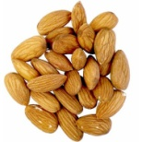
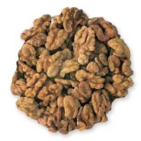
Nuts About Nuts!
U | D | L | G | F | C | P | T | Q | I | C | Y | D | A | O
N | F | Y | N | F | V | B | O | R | A | H | S | A | B | G
S | P | R | I | N | K | L | E | L | T | R | N | L | L | E
A | B | H | K | Y | V | B | I | L | W | Z | A | A | A | N
T | Q | T | A | J | I | F | A | R | X | A | C | S | N | I
U | P | D | B | F | O | E | C | A | L | R | K | F | C | M
R | G | E | E | R | H | T | A | G | E | M | O | R | H | A
A | Y | H | N | T | B | O | Y | U | T | N | L | O | I | T
T | V | I | R | E | E | R | T | S | P | T | U | D | N | I
E | A | A | S | H | E | L | L | D | Q | H | F | L | G | V
D | E | X | D | A | N | T | I | O | X | I | D | A | N | T
H | W | E | I | G | H | T | L | O | S | S | N | W | F | R
N | S | E | I | G | R | E | L | L | A | C | A | Y | C | Z
S | L | A | R | E | N | I | M | B | Y | D | H | L | G | B
P | R | O | T | E | I | N | D | E | T | S | A | O | R | B

Antioxidant | Blanching | Heart Healthy
California | Shell | Unsaturated
Tree | Waldorf Salad | Roasted
Baking | Allergies | Snack
Omega Three | Handful | Weight Loss
Fiber | Vitamin E | Sprinkle
Blood Sugar | Protein | Minerals

