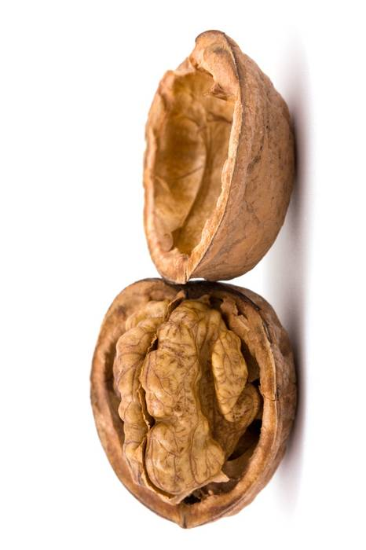

Written and created by Christopher Strand, UW-Stout Dietetic Intern, 01/2011
Using Almonds & Walnuts

The best quality nut should be brittle and snap when broken. Nuts that are rubbery or shriveled indicate that they are old and may be rancid.

Keep the skins on nuts whenever possible. They are an excellent source of fiber and minerals.

Nuts can easily be added to the diet.
Topping for yogurt, fruit, or ice cream
Used in a trail mix or alone for snacking
Added to baking recipes (breads, cookies, etc)
Mixed into your favorite salad
Almonds & Walnuts – Go Nuts!

How eating nuts can benefit your health
Omega-3fatty acids found in these nuts are believed to protect the heart from disease as well as reduce inflammation in the body.
Nuts are high in fiber which can help to reduce cholesterol and control blood sugar.
The protein in nuts can aid in wound repair.
Nuts have Vitamin B6 which can lower blood pressure.
Contain antioxidants which can help protect against cancer.
They are a great source of the minerals manganese and copper which help to maintain bone strength.
Beneficial Bites

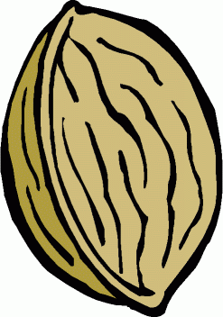
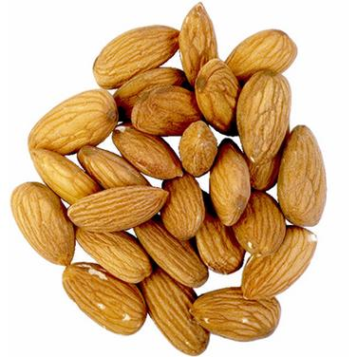
Beneficial Bites

