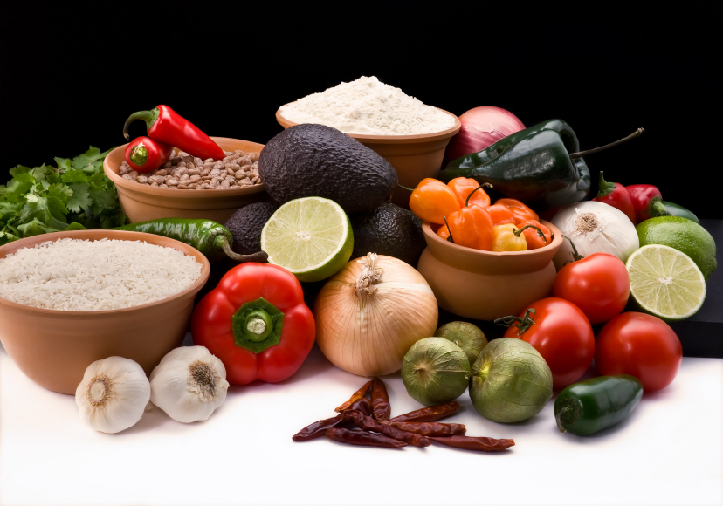
Recipe for: Candied Orange Walnuts
2 cups granulated sugar
1 pound walnut halves
1 teaspoon vanilla extract
2 teaspoons ground cinnamon
4 fluid ounces orange juice

Preheat oven to 350° F. In a bowl, toss 1 cup of sugar with remaining ingredients and mix well.
Pour mixture on to a cookie sheet, spread evenly, and bake for 20 minutes. Remove from oven and sprinkle remaining 1 cup of sugar over the top and mix. Allow walnuts to cool before serving.

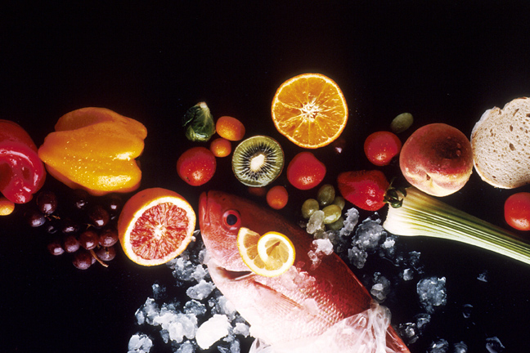
Recipe for: Simple Waldorf Salad
1/2 cup mayonnaise
2 1/2 tablespoons distilled white vinegar
1 crisp apple (peeled, cored, and chopped)
1 large stalk celery, diced
1/2 cup raisins
1/2 cup chopped walnuts
1 teaspoon honey
salt and pepper to taste

In a mixing bowl, whisk together the mayonnaise, vinegar, and honey. Add the apples, celery, raisins and walnuts to bowl and mix well with a spatula. Add salt and pepper to taste. Serve chilled over lettuce (or another green of choice).
Recipe for: Parmesean Walnut Bread
3 cups all-purpose flour
2/3 cup sugar
2/3 cup grated Parmesan cheese
4 teaspoons baking powder
1/2 teaspoon salt
1 egg
1 3/4 cups milk
1/3 cup vegetable oil
1 cup finely chopped walnuts

In a large bowl, combine dry ingredients. In another bowl, beat the egg, milk and oil until smooth. Stir into dry ingredients just until moistened. Fold in the nuts. Pour into a greased 9 x 5 x 3 loaf pan. Bake at 350° F for 50-60 minutes or until a toothpick inserted near the center comes out clean. Cool for 10 minutes before removing from pan to a wire rack.
Recipe for: Zesty Walnut Hummus
1/2 cup walnuts, toasted
1 (19 ounce) can chick peas, drained and rinsed
1/4 cup olive oil
2 tablespoons lemon juice
1 clove garlic, minced
1/2 teaspoon cayenne pepper (or black pepper)

In a blender or food processor, puree walnuts, chickpeas, olive oil, garlic, lemon juice, and cayenne pepper together until smooth. Serve with vegetable sticks, crackers or pita bread.

