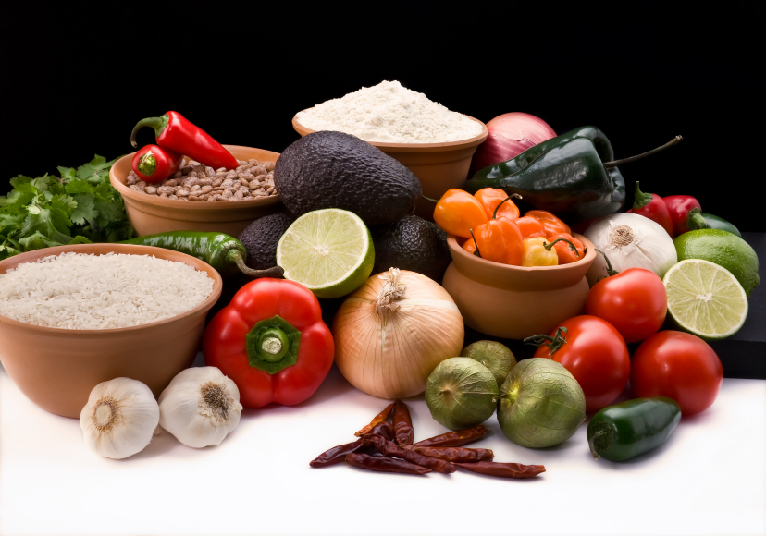
Recipe for: Broccoli with Almonds
1 1/2 pounds fresh broccoli, cut into spears
2 cups water
2 teaspoons chicken bouillon granules (2 cubes)
1/4 cup sliced almonds
2 tablespoons stick margarine
1/2 cup finely chopped onion
1 teaspoon salt

In a large saucepan, bring broccoli, water and bouillon to a boil. Reduce heat; cover and simmer for 5-8 minutes or until broccoli is crisp-tender. Drain and place in a serving dish; keep warm. In a skillet, sauté almonds in margarine until browned. Add onion and salt; sauté until onion is tender. Pour over broccoli; Toss to coat.

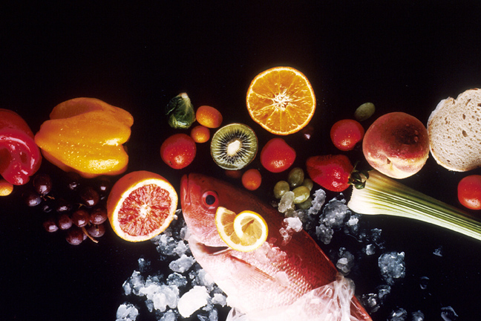
Recipe for: Almond Crusted Walleye
1 1/2 cup sliced almonds
Zest of 1 lemon, finely grated (or 2 tablespoons lemon juice)
1/4 tsp. salt
1/2 tsp. black pepper
2 lbs. walleye fillets
3/4 cup flour
3 eggs, beaten
2 tbsp. butter
2 tbsp. olive oil

In a shallow bowl, combine almonds, lemon zest, salt, and black pepper. Roll each walleye fillet in flour, dip in beaten egg, then gently roll in almond mixture, covering both sides well with all three coatings. In large skillet, heat butter and oil until very hot. Reduce heat to medium and sauté fillets until crispy and brown, about 4 minutes on each side.

Recipe for: Cinnamon Almond Butter
2 cups whole raw almonds
3 tablespoons white sugar
1 tablespoon brown sugar
1 tablespoon ground cinnamon
1 teaspoon salt
1 tablespoon olive oil

Preheat an oven to 350°F. Spread the almonds into a single layer on a baking sheet. Roast almonds until dark brown, about 8 minutes. Allow to cool completely and then blend in a blender (or food processor) until thick and creamy, 8 to 10 minutes. Scrape the sides of the blender with a rubber spatula as needed to keep the almonds blending. Add the white sugar, brown sugar, cinnamon, salt, and olive oil; continue blending until completely smooth. Store in refrigerator. Serve on toast, crackers, or fruit.
Recipe for: Almond Kisses
2 cups whole almonds
2 egg whites
1 cup packed brown sugar
2 tablespoons sifted all-purpose flour

Preheat oven to 300°F. Grease cookie sheets. Chop almonds into 5 or 6 pieces each and set aside. Separate eggs and whip egg whites until stiff. Fold in brown sugar, flour and almonds. Stir lightly. Drop by teaspoonfuls onto cookie sheets and bake about 30 minutes.

