

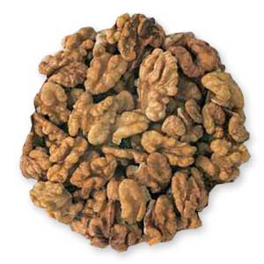

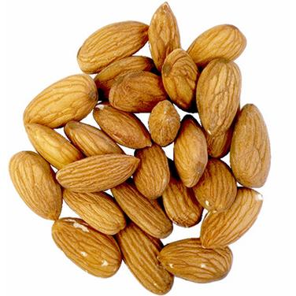

**Almonds**

**& Walnuts**

Health Benefits:

* Anti-inflammatory properties
* Contains nutrients (omega-3’s) essential for heart health
* Rich in Vitamin E to help protect cells and tissue from cancer
* High in fiber to help reduce cholesterol and control blood sugar

Interesting Facts:

* There is no almond in almond bark
* In Ancient Rome, newlyweds were showered with almonds as a fertility charm



* Walnut trees can produce

nuts for over 100 years

* California produces 80% of the world’s almonds
* Chocolate manufacturers use 40% of the world’s almonds
* Both are also used in cosmetics, soaps, shampoos and clothing dye







**Almonds**

**& Walnuts**

Health Benefits:

* Anti-inflammatory properties
* Contains nutrients (omega-3’s) essential for heart health
* Rich in Vitamin E to help protect cells and tissue from cancer
* High in fiber to help reduce cholesterol and control blood sugar

Interesting Facts:

* There is no almond in almond bark
* In Ancient Rome, newlyweds were showered with almonds as a fertility charm



* Walnut trees can produce

nuts for over 100 years

* California produces 80% of the world’s almonds
* Chocolate manufacturers use 40% of the world’s almonds
* Both are also used in cosmetics, soaps, shampoos and clothing dye







**Almonds**

**& Walnuts**

Health Benefits:

* Anti-inflammatory properties
* Contains nutrients (omega-3’s) essential for heart health
* Rich in Vitamin E to help protect cells and tissue from cancer
* High in fiber to help reduce cholesterol and control blood sugar

Interesting Facts:

* There is no almond in almond bark
* In Ancient Rome, newlyweds were showered with almonds as a fertility charm



* Walnut trees can produce

nuts for over 100 years

* California produces 80% of the world’s almonds
* Chocolate manufacturers use 40% of the world’s almonds
* Both are also used in cosmetics, soaps, shampoos and clothing dye

Check out the March menu for these “Nutty” foods

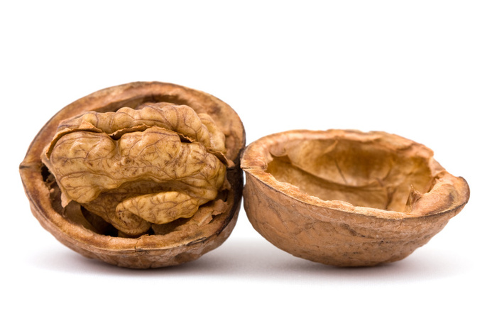

Featured Recipes:

* Almond Crusted Baked Chicken
* Pumpkin Bread Pudding
* Almond Berry Parfait
* Apricot Walnut Bread
* Carrot Cake
* Banana Walnut Cookie
* Craisin Almond Slaw

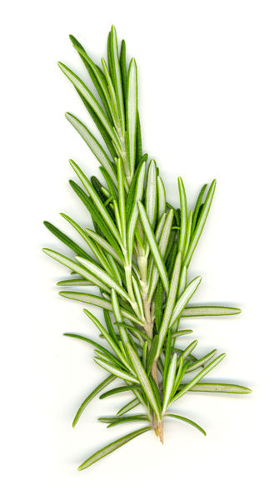

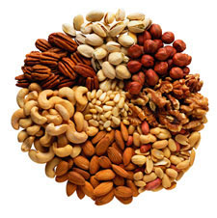Check out the March menu for these “Nutty” foods



Featured Recipes:

* Almond Crusted Baked Chicken
* Pumpkin Bread Pudding
* Almond Berry Parfait
* Apricot Walnut Bread
* Carrot Cake
* Banana Walnut Cookie
* Craisin Almond Slaw



Check out the March menu for these “Nutty” foods



Featured Recipes:

* Almond Crusted Baked Chicken
* Pumpkin Bread Pudding
* Almond Berry Parfait
* Apricot Walnut Bread
* Carrot Cake
* Banana Walnut Cookie
* Craisin Almond Slaw

