Cooking With Nuts
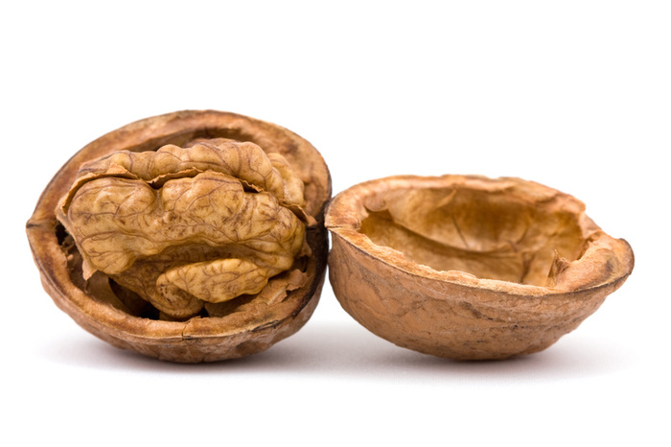
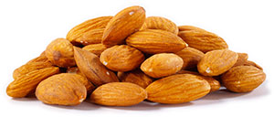

Across
5. Term used when skin is left on the nut. The healthiest way to eat them!
7. Often paired with green beans
11. Cooking by dry heat in an oven (or an open fire!)
12. Not just from cows

Down
1. Treat consisting of sugar and almond paste
2. Varieties include white, black, and English
3. Salad made with apples, celery, and walnuts
4. Process where food is boiled and cooled quickly
6. Fermented milk product perfect for topping with chopped nuts
8. Spreadable substance made by grinding nuts until creamy smooth
9. Walnuts are often added to this chocolate baked good
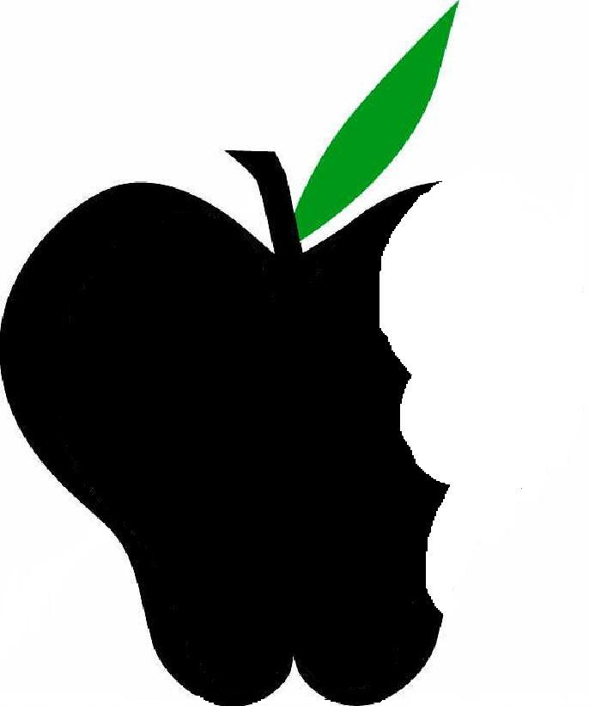
10. Add nuts to batter of this breakfast favorite to boost flavor
Beneficial Bites

