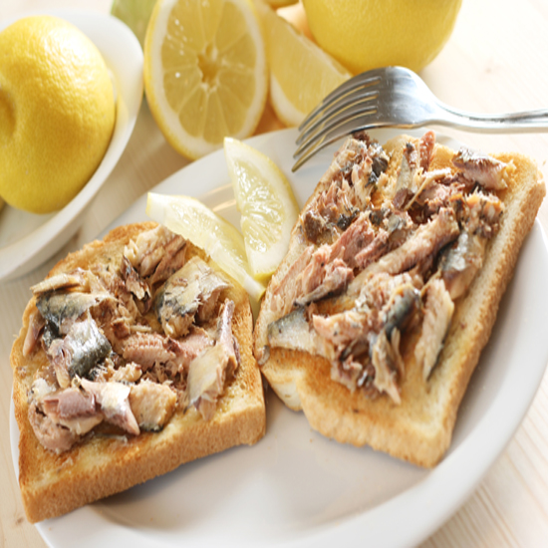  Sardines on Toast  1 package of sardines packed in oil  2 slices of whole wheat bread  2 teaspoons of butter  1 lemon wedge  Directions  Drain the sardines. Toast the bread to preferred doneness. Spread sardine chunks across the toast. Lightly squeeze the lemon over the sardines. |  |  | Strawberry Parfait  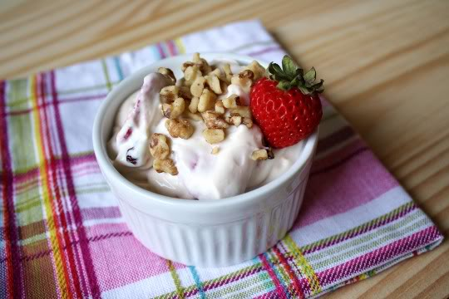  Ingredients  1 cup of vanilla yogurt  ½ cup of strawberries (sliced)  6 Nilla wafers  Directions  Put 3 Nilla wafers in the bottom of a bowl. Cover with half the yogurt. Put half the strawberries on  on the yogurt. Repeat. Place in the refrigerator for 30 minutes or eat right away.  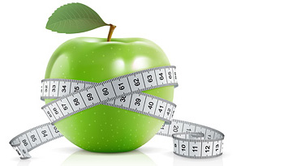 anna cain University of Wisconsin-Stout BS Dietetics |  |  | 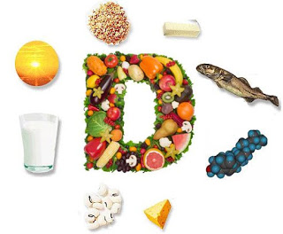  Easy recipes full of vitamin D  - By Anna Cain  University of WI-Stout  BS Dietetics

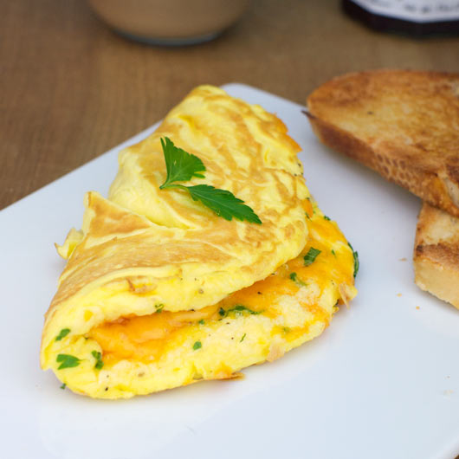  CHEESE & VEGGIE OMELET  Ingredients  2 eggs  1/8 cup of chopped red pepper  1/8 cup of chopped onion  ¼ cup of slice mushrooms  ¼ cup of shredded cheese  1/8 tsp. of dry parsley  1 tsp. of butter |  |  | Omelet Directions  Scramble the eggs and set aside. Chop the pepper and onion. Slice the mushrooms.  Heat a small frying pan on medium heat. Add 1 teaspoon of butter until slightly bubbly. Add the chopped veggies and cook for 2 minutes.  Add the egg to the veggies. Cook for 1 minute. Flip the egg over. Sprinkle with the cheese and parsley. After 1 minute fold the egg in half and place on a plate. Enjoy!  “Vitamin D is, without question, the miracle nutrient of the century.” –Mike Adams |  |  | 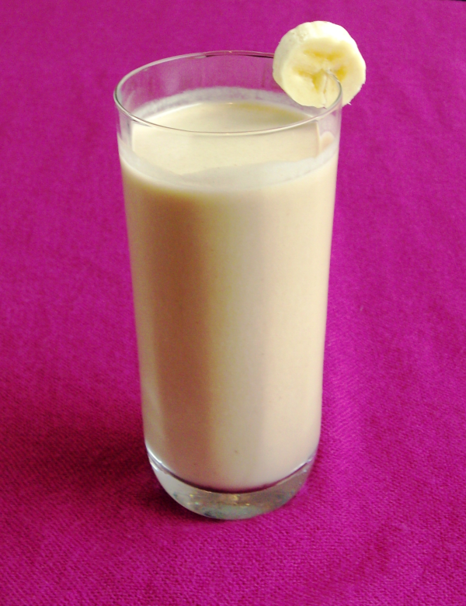  Strawberry Banana Smoothie  Ingredients  1 very ripe banana  ½ cup of strawberry yogurt  1 ½ cups of milk  Directions  Place all ingredients in a blender, food processor, or smoothie maker. Mix for 30 seconds. Pour into a glass and enjoy!

