By Anna Cain
University of Wisconsin-Stout
BS Dietetics

A FOOD GUIDE FOR GOOD NUTRITION
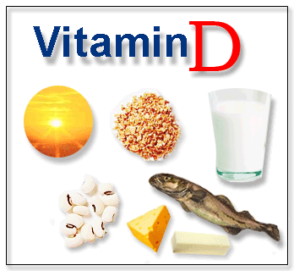

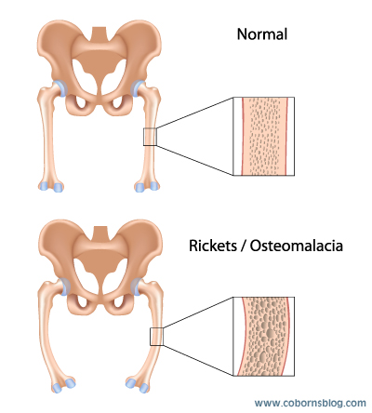

What Happens If You Do Not Get Enough Vitamin D?

Not getting enough Vitamin D makes your bones get soft. This causes them to feel painful and to break easily.
Not having enough Vitamin D will also make your muscles weak. This can lead to falling down often.

What is Vitamin D?

Vitamin D is a substance that acts like a hormone in your body.
Vitamin D dissolves in fats like oil.
Your gut absorbs Vitamin D from the foods you eat.

There Are Two Types of Vitamin D
1. Vitamin D: found in plants and must be activated by the body.
2. Vitamin D3: found in animal products and is already active

What Makes Vitamin D So Great?
Vitamin D allows the body to absorb calcium and phosphorus which keep bones and teeth healthy.
It helps maintain a good immune system.
Vitamin D keeps your veins and arteries working correctly.
It works to keep your heart muscle healthy.
Vitamin D can reduce inflammation.
It also helps reduce insulin resistance.
It’s A Fact!
Unlike other vitamins, Vitamin D cannot be destroyed by cooking.

Where Does Vitamin D Come From?
Sunshine: you need 5-10 minutes 2-3 times per week
Fish: fatty fish like salmon and cod
Fortified foods: cereal, milk, and juices often have Vitamin D added.
Liver: this piece of meat has many vitamins and minerals
Mushrooms: one of the few plants with vitamin D

How Much Vitamin D Do I Need?

For men and women 51-70 years old: 600 IU per day is recommended

For men and women 71 years or older: 800 IU per day is recommended

Amounts may vary based on your doctor’s recommendations.

