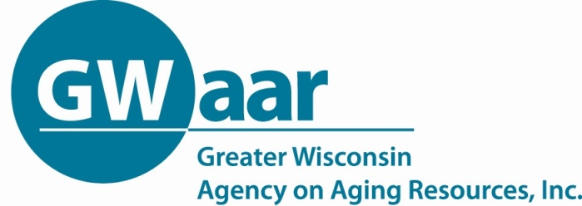
CHECKLIST FOR CHOOSING A PROBLEM AND ISSUE
To compare issues and choose the best focus for your campaign, either use this checklist of criteria or develop your own. List the issues under consideration in the columns, and go down the list of questions, recording a “1” for every “yes” answer and a “0” for every “no” answer. Problems/issues with higher scores have the potential for multiple positive results.

Problem/Issue 1: | Problem/Issue 2: | Problem/Issue 3: | Will resolving the problem/  Will the issue:
 |  |  | - Result in a real improvement in people’s lives?
 |  |  | - Give people a sense of their own power?
 |  |  | - Build strong lasting organizations and alter the relations of power?
 |  |  | - Raise awareness about power relations and democratic rights?
 |  |  | - Be winnable?
 |  |  | - Be widely felt?
 |  |  | - Be deeply felt?
 |  |  | - Be easy to communication and understand?
 |  |  | - Provide opportunities for people to learn about and be involved in policies?
 |  |  | - Have clear advocacy targets?
 |  |  | - Have a clear time frame?
 |  |  | - Be non-divisive among your potential constituency?
 |  |  | - Build accountable leadership?
 |  |  | - Be consistent with your values and vision?
 |  |  | - Provide potential for raising funds?
 |  |  | - Link local issues to global issues and macro policy context?

Adapted from A New Weave of Power, People, and Politics: The Action Guide for Advocacy and Citizen Participation by Lisa VeneKlasen with Valerie Miller, and from Organizing for Social Change: A Manual for Activists in the 1990s by Kim Bobo, Jackie Kendall, and Steve Max.

