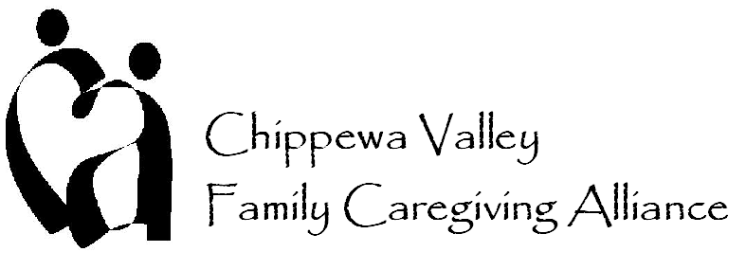

Member Benefits

- Opportunity to shape family caregiving in your community, while developing a broader knowledge of caregiving resources in the Chippewa Valley

- Educational speakers and topics help to enhance your caregiving efforts

- Provides additional training opportunities to enhance your caregiving experience

- Access to member e-mail distribution list of local family and professional caregivers

- Annual networking social event to help you better connect with local family and professional caregivers

- Enables you to easily share and learn about caregiving resources and opportunities in the Chippewa Valley through meetings, e-mail distribution list and our organizational website www.chippewavalleycaregiving.org

- Provides you with voting rights so that you can help steer the current and future endeavors of the organization

- Gives you the opportunity to become involved in caregiving issues that are important to you through our vast array of committees:
• Advocacy
• Caregiving in the Workplace
• Connecting Caregivers with Services through Health Care Providers
• Events: Town Hall Meeting, Sacred Heart Hospital – Caring for the Caregiver
Conference, Luther Vendor Fair, Senior American’s Day and Others
• Website

- Offers professional caregivers a presence at the CVFCA’s annual Town Hall Meeting and a business link on our organizational website www.chippewavalleycaregiving.org

- New member folders, pin and recognition

- Low yearly dues - $10 for family caregivers and $30 for professional caregivers

- Lunch at all the meetings

- And more!

