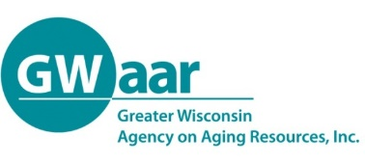
Vision Statements
A vision statement is a global concept; a dream of the way things ought to be and a mental image of what success would look like.
Examples of Vision Statements
- Family caregivers in our community are able to live balanced lives and have the caregiving supports and services they need
- Caregivers and care recipients will have the best possible quality of care
- All caregivers in our community will be valued, respected and supported and will have easy access to information, education and services.

Mission Statements
A mission statement is the group’s declaration of purpose: what you are going to do to accomplish your vision. A mission statement should:
- Describe what will be accomplished and why
- Be concise (preferably one sentence)
- Be outcome oriented, stating a broad goal to be achieved

Examples of Mission Statements
- To advocate through empowering, encouraging, and educating both family and community caregivers so that they can improve the quality of life for the caregiver and the care receiver.
- To advocate for resource development as identified by family caregivers and promote easy access for family caregivers to informational materials, community education events, and support groups.
- To support and strengthen family caregivers of older adults through advocacy, education, and community resources
- To promote community awareness of, sensitivity to, and generate action for improvement on caregiving issues in our community
- To provide resource information, support, and advocacy for all caregiving concerns and to enhance the quality of life to all those touched by these concerns.
- To recognize, educate, support, and motivate family caregivers.
- Dedicated to providing awareness, education, support, advocacy, and resources to facilitate community partnerships for caregivers
- To improve the quality of life for seniors and their support systems by developing and sharing information through education, events and networking
- To bring diverse organizations together to share and coordinate existing resources, identify gaps in services and develop solutions in order to foster support and independence for families and older adults.

