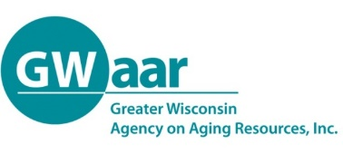
Potential Coalition Partners

- ADRC’s
- Adult Day Centers
- Adult Family Homes
- Alzheimer’s Association
- American Red Cross
- Assisted Living Facilities
- Catholic Charities
- Center for Independent Living
- Churches – Faith-based Communities
- Disability Groups
- Eldercare Attorneys
- Existing Coalitions that Interface with Caregiving Issues
- Family Caregivers
- Foundation Groups (Cancer, Epilepsy, Heart, etc.)
- Funeral Directors
- Home Care Agencies
- Home Medical Suppliers
- Home Organization/Repair
- Hospice Care Agencies
- Hospitals/Clinics
- Human Resource Directors/Wellness Coordinators
- Interfaith Caregiver Agencies
- Local Businesses
- Lutheran Social Services
- Managed Care Organizations
- Media (print, radio, TV)
- Mental Health Services
- Nursing Homes
- Pharmacists
- Political Leaders/Elected Officials
- Senior Apartment Managers
- Senior Center Directors
- Service Organizations (Kiwanis, Optimists, Lions, Rotary, etc.)
- Support Group Facilitators
- Transportation Agencies
- United Way
- University or Technical College Staff
- UW Extension
- Veterans Organizations
- Other…
Tips for Building and Securing Partnerships

- Decide who is needed at the table (from list, and more)
  - Know your community
  - Who are the leaders?
  - Who do you know?
  - Who shares your vision?
- Identify those with leadership experience, a reputation for collaboration and obvious investment in family caregiving
- Share your mission statement
- Be clear about your goals and objectives
- Talk about what they will get from participating (“what’s in it for me”)
- Explain how caregivers lives better because of the work of the coalition

