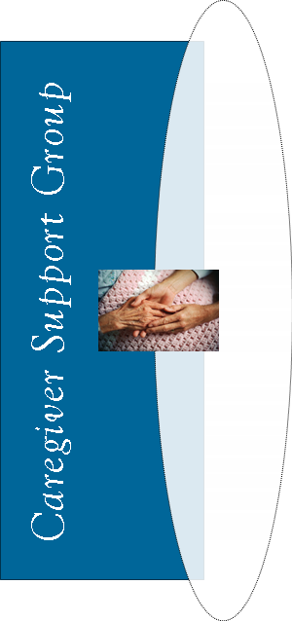
TOPIC:

Tips for Nutritious Eating
Learn some simple ways you can improve nutrition for your loved one.
Guest Speaker: Betty Crocker, Nutrition Coordinator, Any County Aging Unit

Your Town Hospital

1234 Wellness Road
Any City
*call for more info (or call to register)
Wednesday, June 5
9:00 to 10:30 a.m.
Wednesday, June 5
9:00 to 10:30 a.m.

Your Town Hospital

1234 Wellness Road
Any City
*call for more info (or call to register)
TOPIC:

Tips for Nutritious Eating
Learn some simple ways you can improve nutrition for your loved one.
Guest Speaker: Betty Crocker, Nutrition Coordinator, Any County Aging Unit
TOPIC:

Tips for Nutritious Eating
Learn some simple ways you can improve nutrition for your loved one.
Guest Speaker: Betty Crocker, Nutrition Coordinator, Any County Aging Unit

Your Town Hospital

1234 Wellness Road
Any City
*call for more info (or call to register)
Wednesday, June 5
9:00 to 10:30 a.m.

Your Town Hospital

1234 Wellness Road
Any City
*call for more info (or call to register)
Wednesday, June 5
9:00 to 10:30 a.m.
TOPIC:

Tips for Nutritious Eating
Learn some simple ways you can improve nutrition for your loved one.
Guest Speaker: Betty Crocker, Nutrition Coordinator, Any County Aging Unit

