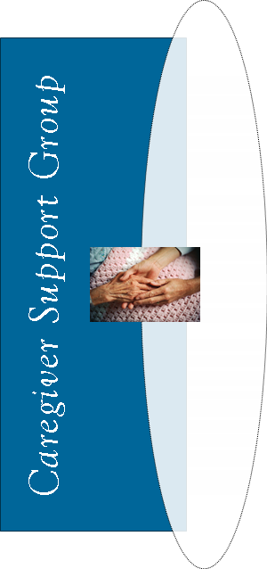
TOPIC:
Music Can Improve Your Life Everyone can benefit from listening to or playing music. Find out why and how to include music in your caregiving routine.
Guest Speaker: Bill Brass, Music Therapist

Your Town Hospital

1234 Wellness Road
Any City
*call for more info (or call to register)
Wednesday, June 5
9:00 to 10:30 a.m.
Wednesday, June 5
9:00 to 10:30 a.m.

Your Town Hospital

1234 Wellness Road
Any City
*call for more info (or call to register)
TOPIC:
Music Can Improve Your Life Everyone can benefit from listening to or playing music. Find out why and how to include music in your caregiving routine.
Guest Speaker: Bill Brass, Music Therapist

TOPIC:
Music Can Improve Your Life Everyone can benefit from listening to or playing music. Find out why and how to include music in your caregiving routine.
Guest Speaker: Bill Brass, Music Therapist

Your Town Hospital

1234 Wellness Road
Any City
*call for more info (or call to register)
Wednesday, June 5
9:00 to 10:30 a.m.

Your Town Hospital

1234 Wellness Road
Any City
*call for more info (or call to register)
Wednesday, June 5
9:00 to 10:30 a.m.
TOPIC:
Music Can Improve Your Life Everyone can benefit from listening to or playing music. Find out why and how to include music in your caregiving routine.
Guest Speaker: Bill Brass, Music Therapist

