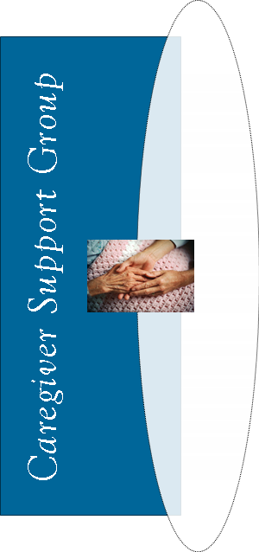
TOPIC:
Age-Related Issues and Driving Find out how aging affects driving and what to do if you’re concerned about your loved one driving.
Guest Speaker: The Drive Guy, Wisconsin DMV

.

Your Town Hospital

1234 Wellness Road
Any City
*call for more info (or call to register)
Wednesday, June 5
9:00 to 10:30 a.m.
Wednesday, June 5
9:00 to 10:30 a.m.

Your Town Hospital

1234 Wellness Road
Any City
*call for more info (or call to register)
TOPIC:
Age-Related Issues and Driving Find out how aging affects driving and what to do if you’re concerned about your loved one driving.
Guest Speaker: The Drive Guy, Wisconsin DMV

TOPIC:
Age-Related Issues and Driving Find out how aging affects driving and what to do if you’re concerned about your loved one driving.
Guest Speaker: The Drive Guy, Wisconsin DMV

Your Town Hospital

1234 Wellness Road
Any City
*call for more info (or call to register)
Wednesday, June 5
9:00 to 10:30 a.m.

Your Town Hospital

1234 Wellness Road
Any City
*call for more info (or call to register)
Wednesday, June 5
9:00 to 10:30 a.m.
TOPIC:
Age-Related Issues and Driving Find out how aging affects driving and what to do if you’re concerned about your loved one driving.
Guest Speaker: The Drive Guy, Wisconsin DMV

