Medicare Resource Kits

Primary purpose: To display Medicare/MIPPA information and resources throughout the county

Examples of Resources to include:
- ADRC/EBS brochures
- List of Medicare Resources
- MIPPA brochures and HP Inserts
- Welcome to Medicare Flyers
- Medicare Preventive Services Chart
- Annual Open Enrollment Flyers
- Others
Examples of Places to offer the Medicare Resource Kits:
- All Public Libraries (Discuss with reference librarians)
- Food Pantries
- Senior Centers
- Senior Dining Sites
- Churches
- Clinics and Hospitals

**Where to purchase the kits: Resource Kits such as the one in the attached photo can be found at many locations. The one pictured was purchased through Affordable Display Products, Inc., www.affordabledisplayproducts.com 1-866-550-0656

**Sticker Templates: Customize with your agency’s contact information and print on full page sticker sheets that can be purchased at office supply stores. Then cut out and adhere to the resource kits.

Elder Benefit
Specialist Program
(262) 548-7848

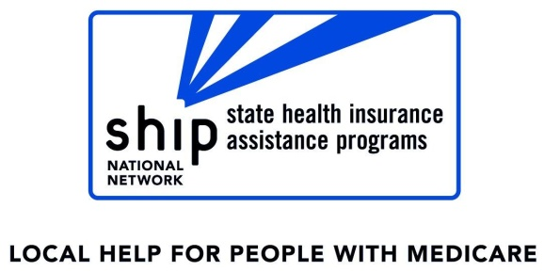
Local
Help for
People
With
Medicare
Helping
Leaders
in Aging
Succeed!
Medicare &
Medicare Related Programs

For questions about private or government benefits,
Contact the
Elder Benefit Specialists
(262)548-7848

