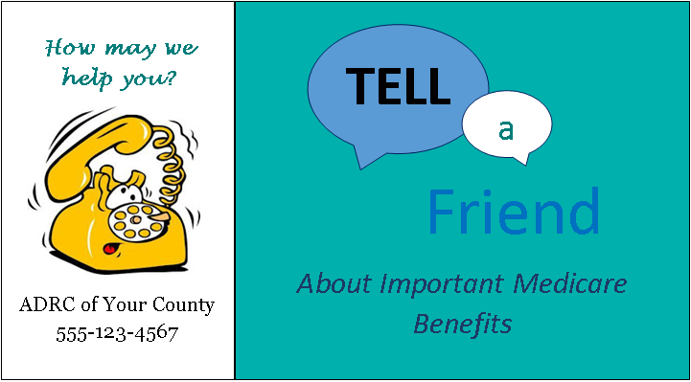



Friend

ADRC of Your County
555-123-4567
About Important Medicare Benefits

How may we help you?
TELL
a

If you know of anyone who may benefit from these programs, please spread the word!
Do you know your benefits?
Preventive Services are now covered by Medicare
Senior Care is an alternative prescription drug plan available to all Wisconsin residents
Medicare Savings Programs cover the Medicare premium for those with limited income and assets
Extra Help reduces Medicare Part D costs for those with limited income and assets

If you know of anyone who may benefit from these programs, please spread the word!
Do you know your benefits?
Preventive Services are now covered by Medicare
Senior Care is an alternative prescription drug plan available to all Wisconsin residents
Medicare Savings Programs cover the Medicare premium for those with limited income and assets
Extra Help reduces Medicare Part D costs for those with limited income and assets
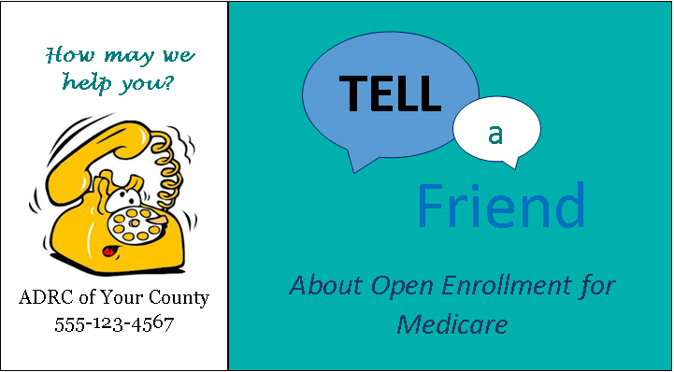

Friend

ADRC of Your County
555-123-4567
About Open Enrollment for Medicare

How may we help you?
TELL
a

Medicare Open Enrollment
October 15 – December 7
Review your Medicare Part D Prescription Drug Plan!
Why review??
Plan may cost more next year
Plan may not cover all your medications in the same way
You might be taking new medications
Get screened for money saving programs
Schedule an appointment by calling ADRC of Cheddar County
555-123-4567

Medicare Open Enrollment
October 15 – December 7
Review your Medicare Part D Prescription Drug Plan!
Why review??
Plan may cost more next year
Plan may not cover all your medications in the same way
You might be taking new medications
Get screened for money saving programs
Schedule an appointment by calling ADRC of Cheddar County
555-123-4567

