Sample “Tell a Friend” Letter – Medicare Presentation
<USE YOUR AGENCY LETTERHEAD>

<MONTH, YEAR>

Dear <XXX>:

Thank you for attending the A-B-C’s of Medicare presentation held by <AGENCY> last <SEASON, e.g. spring>. I hope you found it interesting and educational, and continue to see the benefits of using what you learned.

<AGENCY> will be offering an A-B-C’s of Medicare presentation again this upcoming <DATE>. I am writing to ask you to help promote our next presentation by passing along these brochures/flyers to friends or neighbors who may also be interested in learning about Medicare.

As a reminder, the presentation covered basic information about:

- Medicare Part A
- Medicare Part B
- Medicare Part D
- Senior Care
- Medicare Advantage Plans
- Medicare Supplements
- Medicare Preventive Services
- Ways to cover the costs of Medicare (Medicare Savings Plans and Extra Help)
- Question/Answer session

Thank you for helping to spread the word about this upcoming presentation. If you have any questions or would like more brochures/flyers, feel free to call me at <NUMBER>.

Kind regards,

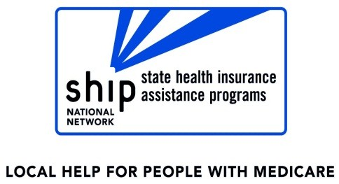
<NAME>
<TITLE>
<AGENCY>

Sample “Tell a Friend” Letter - OEP
<USE YOUR AGENCY LETTERHEAD>

<Date>

Dear <insert name>:
Thank you for coming in to review your Medicare Part D plan. I am writing to ask you to help promote our services by passing along these postcards to your friends or neighbors who may not have reviewed their prescription drug plans for 2016. Appointments can be made by calling the <ADRC of Cheddar County at 555-123-4567>. The dates and locations of the appointments are listed below:
<Insert appointment locations and dates here>
Here are three good reasons everyone should have their prescription drug plans reviewed every year:
  - Insurance companies can change their premiums, deductibles and co-pays every year, so switching to a different plan often results in saving money.
  - Insurance companies can change the medications they cover or the way they cover them. This means that a medication that was covered well in 2015 might not be covered at all in 2016.
  - Part of the review process includes a screening for money-saving programs that reduce the cost of insurance premiums, deductibles and co-payments.
Thank you for helping to spread the word! If you have any questions or would like more postcards, feel free to call me at <555-123-4567>.
Kind regards,

<NAME>
<TITLE>
<AGENCY>

