









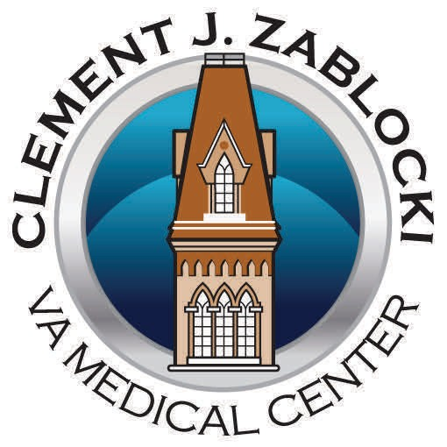
Self-Direction

Wisconsin
Veteran Self-Directed Program

• The Veteran decides how to live his or her own life.
• The Veteran has authority and
responsibility over a specific budget.
• The Veteran decides who he or she wants to provide care including family members, friends, and
neighbors.
• The Veteran decides where and when care and supports are to be
provided.

A Partnership with
Clement J. Zablocki VA Medical Center (VAMC), Wisconsin Department of Health Services, and
Greater Wisconsin Agency on Aging Resources (GWAAR)
Wisconsin Veteran Self-Directed Program

What is the Wisconsin Veteran
Self-Directed Program?

The Wisconsin Veteran Self-Directed Program allows Veterans and their families choose the services and supports they need to be able to safely and successfully live at home.

Who can participate?

• Veterans enrolled in primary care with the Clement J. Zablocki VAMC
• Veterans who want to remain living
at home but are at risk of needing nursing home care or Veterans in nursing home care who can safely transition home;
• Veterans who have a service connected disability;
• Veterans who are able and willing to self-direct their services;
• Veterans who may want their


family, friends, and/or neighbors to provide services and supports.



What services are available?

Allowable services include but are not limited to:

• Personal Care
• Homemaker/Supportive Home
Care
• Adult Day Care
• Assistive Technology
• Home-Delivered Meals
• Homemaker Caregiver Support
• Respite Care
• Environmental Support
• Other goods and services needed to remain safely in the community

How does it work?

VAMC staff identify and refer the Veteran to the Care Consultant at the Greater Wisconsin Agency on Aging Resources (GWAAR). The GWAAR Care Consultant conducts a thorough assessment with the Veteran to identify needs, preferences, and strengths and determine the monthly budget.
How does the Veteran receive goods and services?

The Veteran, in conjunction with the Care Consultant develops a Care Plan that identifies the service needs. The Veteran decides who they want to provide the needed services-including family, friends, and neighbors- and determine how much they will pay the individual. The Care Consultant works with the Veteran to identify, hire, train, and monitor service provision and payment for services.

Additionally, a Fiscal Manager assists the Veteran with ensuring timely payments are made for goods and services. If any changes occur, the Care Plan is adjusted to meet the new needs of the


Veteran.

