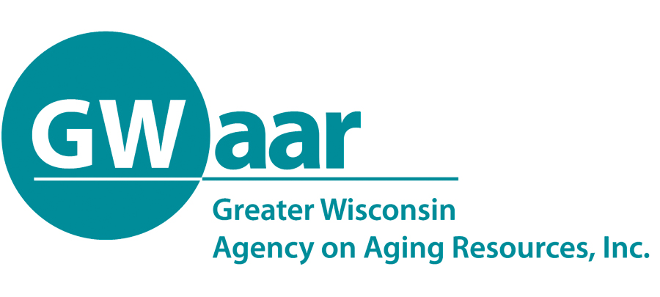

EBS Webcast Training Agenda
____________________________________________________________________________________________________
Main Office: 1414 MacArthur Road, Suite A ∙ Madison, WI 53714 ∙ Phone: 608.243.5670 ∙ Fax: 866.813.0974 ∙ www.gwaar.org

Wednesday, February 12, 2020
9:00 a.m. – 12:00 p.m.

Live Training Location: Room B155 at DHS,
1 West Wilson, Madison

Link to Webcast: https://livestream.com/DHSWebcast/EBSTraining

9:00-9:45 | Working with Clients who Need Interpreters | Laura Steigerwald and Christine Huberty, GWAAR
9:45-10:15 | Promoting Better Health for People with Medicare | Debbie Bisswurm and Angie Sullivan, GWAAR
10:15-10:30 | Break
10:30-11:15 | BadgerCare+ Reform | Nicholas Di Meo, MPH  DHS Health Policy Advisor
11:15–12:00 | Case Law Update | Kate Schilling

Training materials will be posted on the EBS portion of the www.gwaar.org
____________________________________________________________________________________________________
Main Office: 1414 MacArthur Road, Suite A ∙ Madison, WI 53714 ∙ Phone: 608.243.5670 ∙ Fax: 866.813.0974 ∙ www.gwaar.org

prior to the webcast.

This is a mandatory training. EBS who are unable to watch the live webcast will need to watch the archived version of the training at a later date during the month of February.

